**Installation Note for GPCC**

We offer two versions of GPCC for the users, the light version (less than 5 MB) and the standalone version (About 833 MB). The light-version GPCC is provided for the users who have a MATLAB (2017b or above) installed on his computer, while the standalone-version GPCC can be directly installed on your computer without the library support from MATLAB.

* The light-version GPCC can be archived from:

<https://github.com/Jiechenwhu/GPCC>

* The standalone-version GPCC can be archived from:

<https://github.com/Jiechenwhu/GPCC_StandalonePackage>

# 1. Installation Note for the Light-version GPCC

There are two circumstances when you can use this light version of GPCC:

(1) You do have a **MATLAB 2017b** installed on your computer, but a lower MATLAB version may not be supported.

(2) Download and install the **MATLAB 2017b runtime (R2017b 9.3)** from the MathWorks official website (<https://www.mathworks.com/products/compiler/matlab-runtime.html>).

(**What is the MATLAB runtime**: *The MATLAB Runtime is a standalone set of shared libraries that enables the execution of compiled MATLAB applications or components on computers that do not have MATLAB installed.)*

**Installation Step**

(1) Download the light-version GPCC from the author’s GitHub repository.

GPCC_Light repository (<https://github.com/Jiechenwhu/GPCC>)

GPCC_Light package contains 5 files: the icon file (**default_icon.ico**), the executive file (**GPCC_GUI.exe**), the readme text file (**readme.txt**) and the splash figure (**splash.png**) and the installation note (**GPCC_Light_Notes.docx**).

(2) Double click the **GPCC_GUI.exe** to get started.

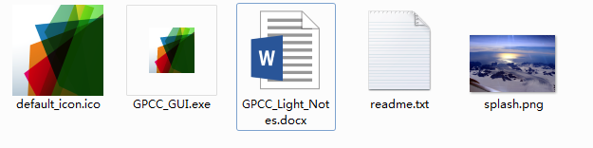

(3) A splash will be shown on your computer when GPCC is started.



(4) When you see the welcome page for GPCC, click ‘Enter’ to use GPCC.

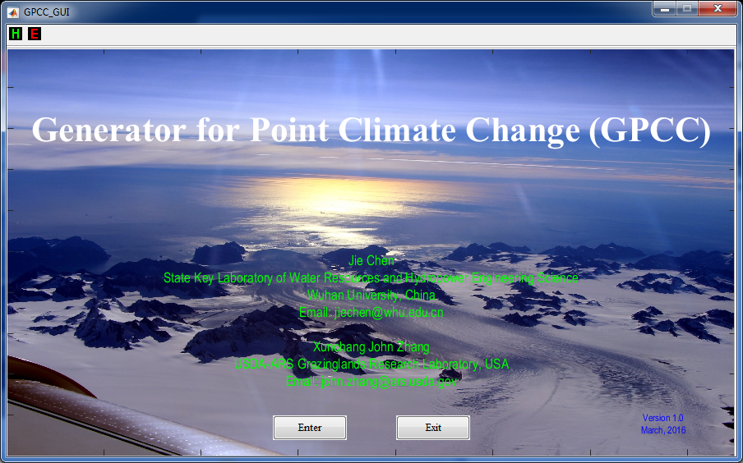

# 2. Installation Note for the Standalone-version GPCC

If you do not use MATLAB, or you do not have a MATLAB (2017b and above) installed on your computer, you can try to use the standalone-version GPCC.

The standalone-version GPCC is a software provided for 64-bit Windows.

(1) Download the light-version GPCC from the author’s GitHub repository.

GPCC_standalone repository <https://github.com/Jiechenwhu/GPCC_StandalonePackage>).

(2) There are 42 compressed files need to be downloaded. After finishing downloading, SELECT ALL and decompress these file simultaneously and then you will get a folder named GPCC.

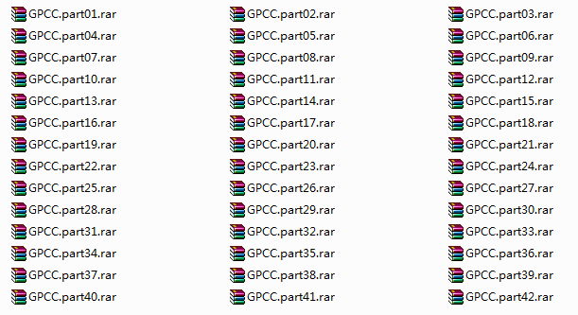



(3) Enter the GPCC folder, and Double click the file GPP.exe to run it.

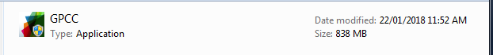

(4) Click the button “Next”.

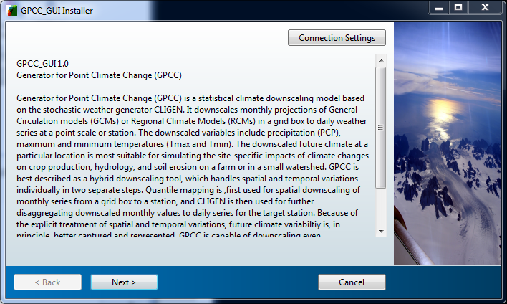

(5) Choose the installation path for GPCC. And if you want to create a shortcut for GPCC in your desktop, tick the option “Add a shortcut to the desktop”.

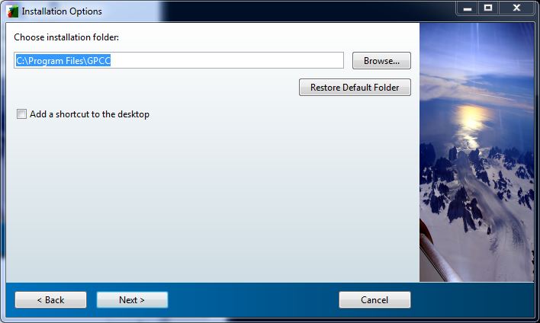

(6) Choose the installation path for the MATLAB runtime.

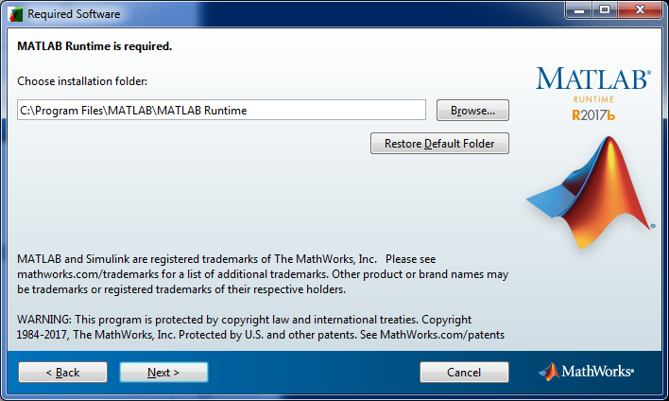

(7) Go through the license agreement set by MathWorks, and then click “Yes” to reach the next step.

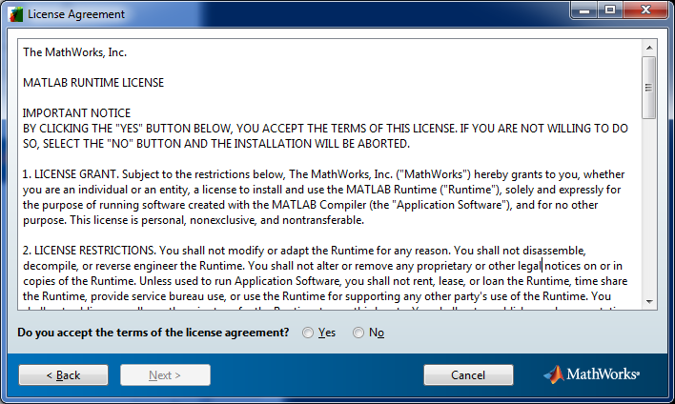

(8) Confirm the installation information and click “install” to install GPCC.

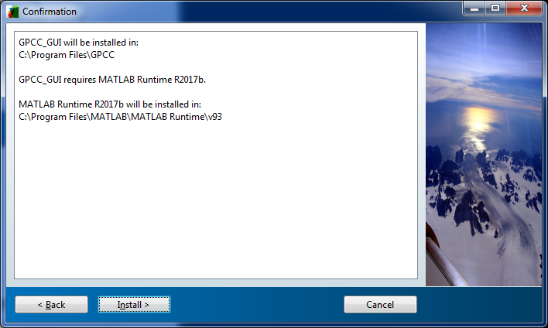

(9) It will take about 5-10 minutes to get installed.

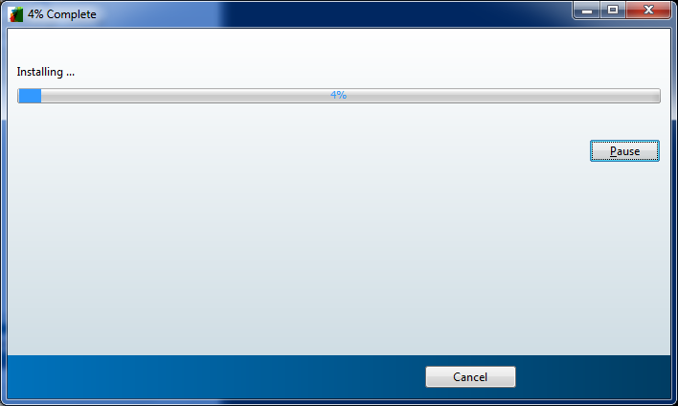

(10) When the installation is completed, click “finish”.

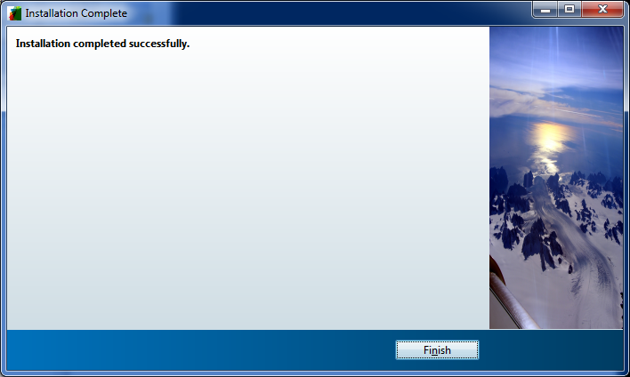

(11) You can start GPP by double-clicking the shortcut in your desktop (If selected in the previous step) or the shortcut in your start menu.

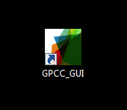

(12) A beautiful picture will be shown on your computer when GPCC is started.



(13) Now you will see the interface of GPCC, and use GPCC for your project.

